**Data Collection and Preprocessing Phase**

|  |  |
| --- | --- |
| Date | 13 June 2024 |
| Team ID | SWTID1749709340 |
| Project Title | Predicting Co2 Emission by countries Using Machine Learning |
| Maximum Marks | 6 Marks |

**Data Exploration and Preprocessing Template**

Identifies data sources, assesses quality issues like missing values and duplicates, and implements resolution plans to ensure accurate and reliable analysis.

|  |  |
| --- | --- |
| **Section** | **Description** |
| Data Overview | Basic statistics, dimensions, and structure of the data. |
| Univariate Analysis | Exploration of individual variables (mean, median, mode, etc.). |
| Bivariate Analysis | Relationships between two variables (correlation, scatter plots). |
| Multivariate Analysis | Patterns and relationships involving multiple variables. |
| Outliers and Anomalies | Identification and treatment of outliers. |
| **Data Preprocessing Code Screenshots** | |
| Loading Data | Code to load the dataset into the preferred environment (e.g., Python, R). |
| Handling Missing Data | Code for identifying and handling missing values. |

**DATA OVERVIEW:**

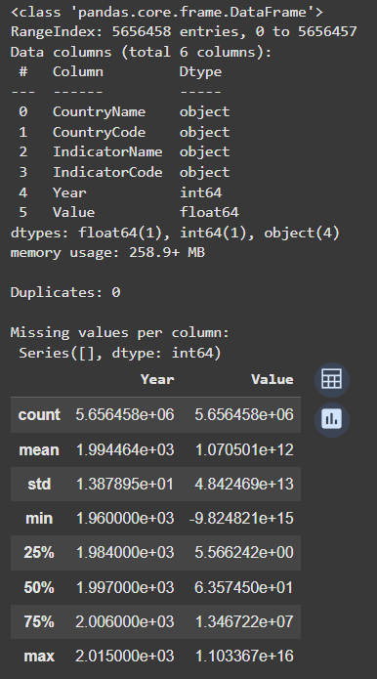

**UNIVARIATE ANALYSIS:**

**FOR NUMERICAL DATA:**

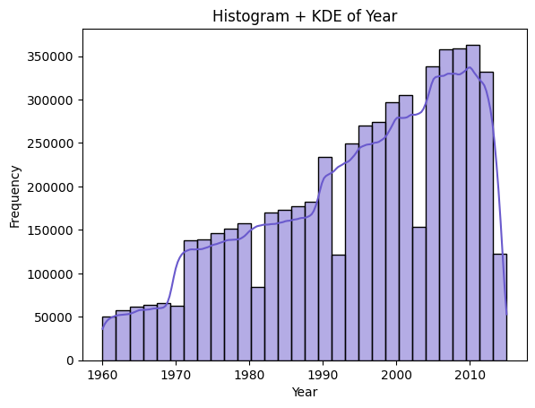

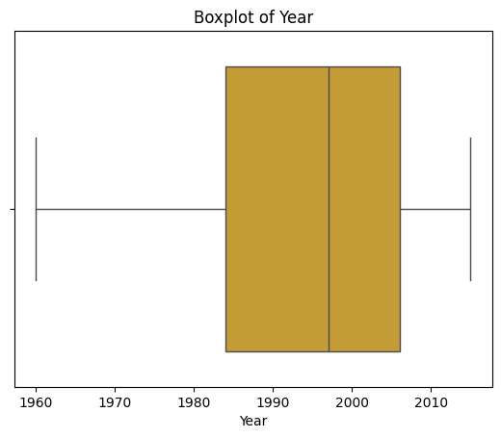

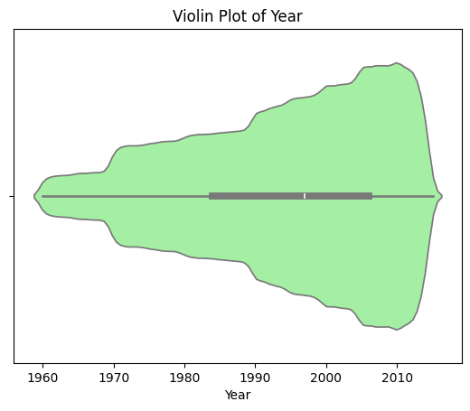

**FOR CATEGORICAL DATA:**

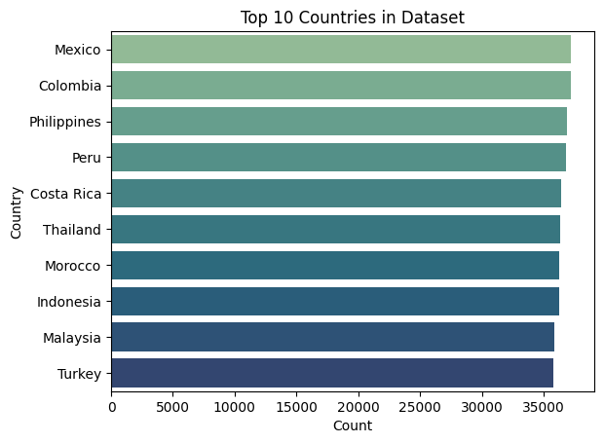

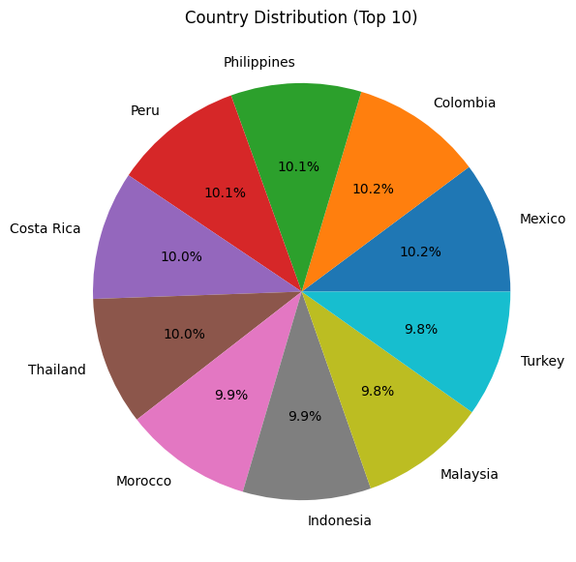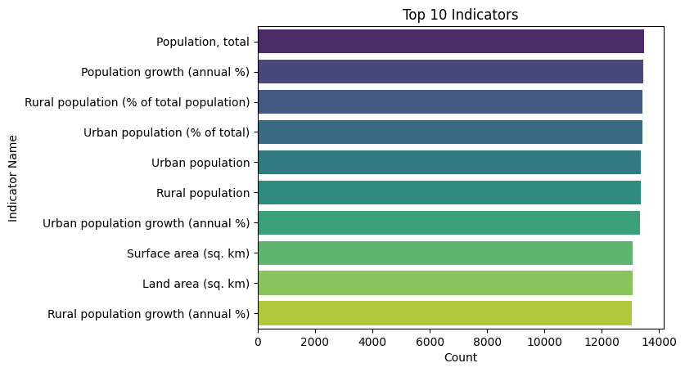

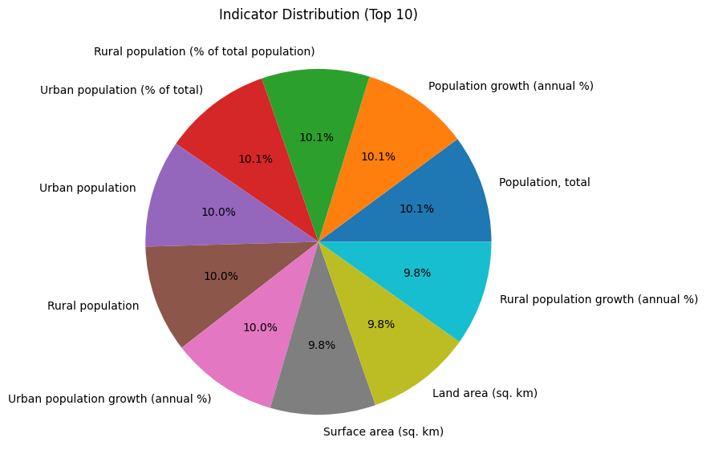

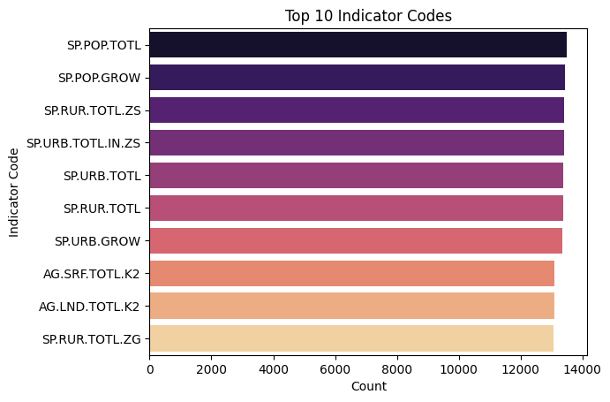

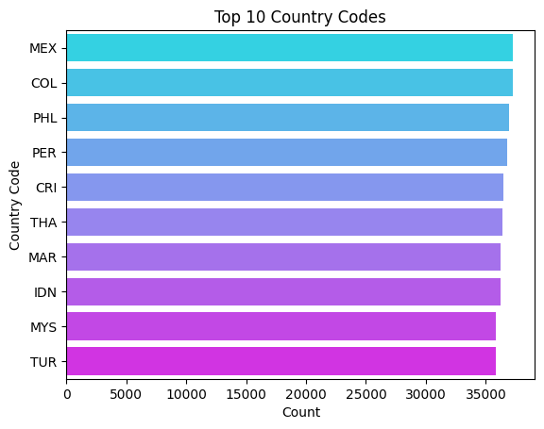

**BIVARIATE ANALYSIS:**

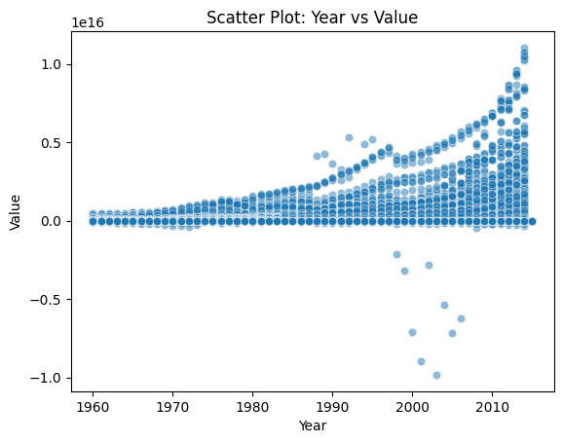

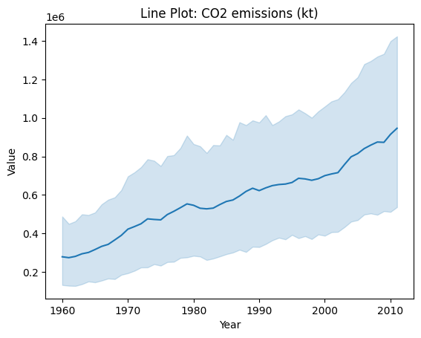

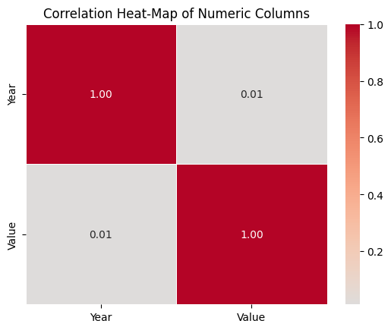

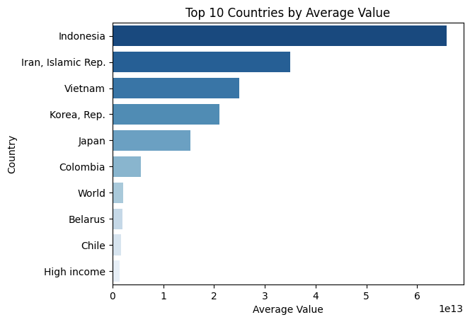

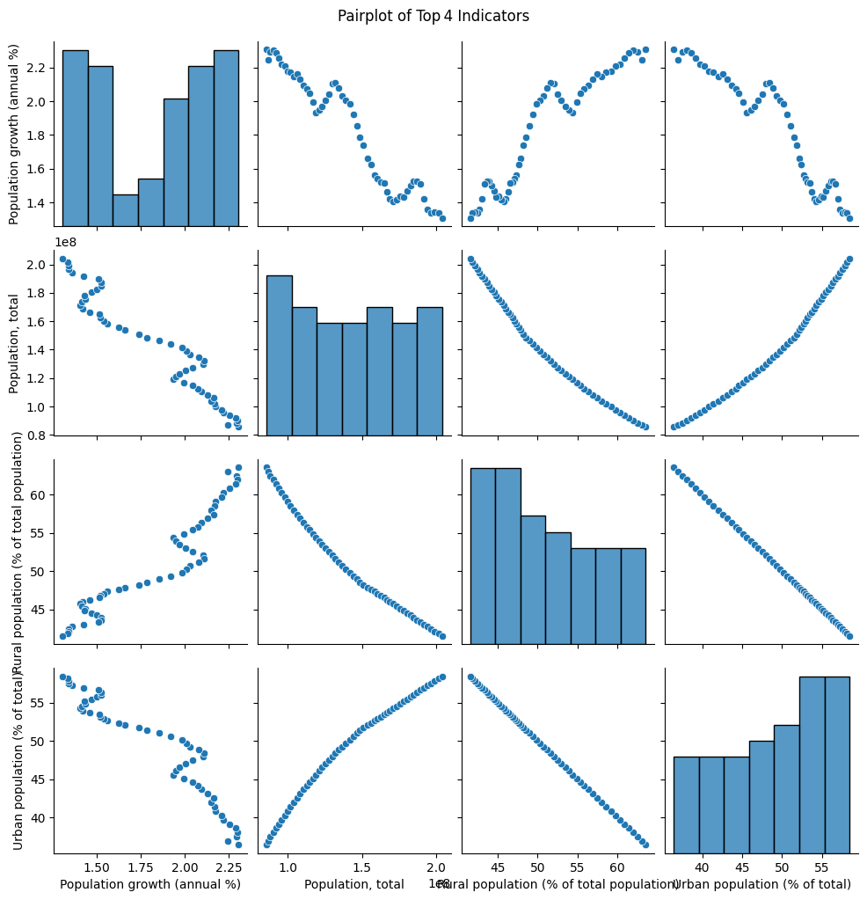

**LOADING DATA:**

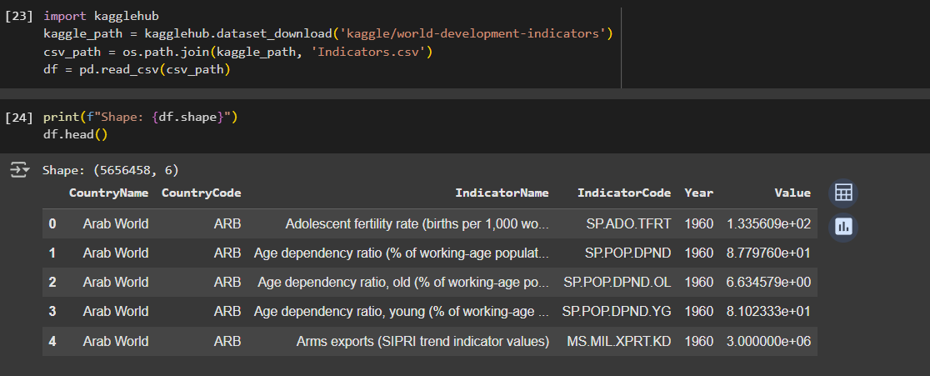

**HANDLING MISSING DATA:**

